Printing Purchase Orders

Navigation for Printing the Purchase Orders

1. Purchasing Purchase Orders Review PO Information Print PO’s

2. Click on the yellow Search button on the Purchase Orders Print screen. A Run Control ID will need to be established if you don’t have one.
3. Enter your PO # in the PO ID field. Click the yellow Run button.

4. Click on the yellow OK button.

5. Click on Process Monitor link that is highlighted in blue.

6. Click on the yellow Refresh button until the Run Status reads Success.

7. Click on the word Details – highlighted in Blue.
8. Click on View Log/Trace – highlighted in blue

9. Click on the PDF link

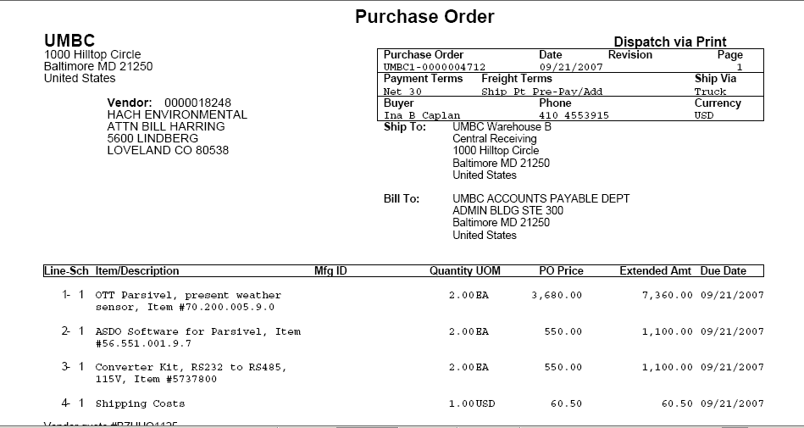
10. Print out a copy of the Purchase Order.

