Reference Guide - Entering Receipts

- Navigation: Purchasing Receipts Add/Update Receipts
Receipts are auto-numbered by PeopleSoft.

- Select the Business Unit UMBC1 if the value did not default in.
- Do NOT make any changes to the other fields on this page.
- Just click the Add button to move to the next page, shown below
ENTER THE COMPLETE PO # #ID

- Enter your PO ID.
- Click on . DO NOT hit the ENTER button on your keyboard.

TROUBLE-SHOOTING:
If no rows are returned, clear the “Ship To” Field & remove the green checkmark in the “OpenSched” field. If you do not know the PO ID, search for shipments by vendor name. Enter the first 3 letters of the vendor name in the “ShortName” field, then click the magnifying glass. Select your Vendor and then click SEARCH.

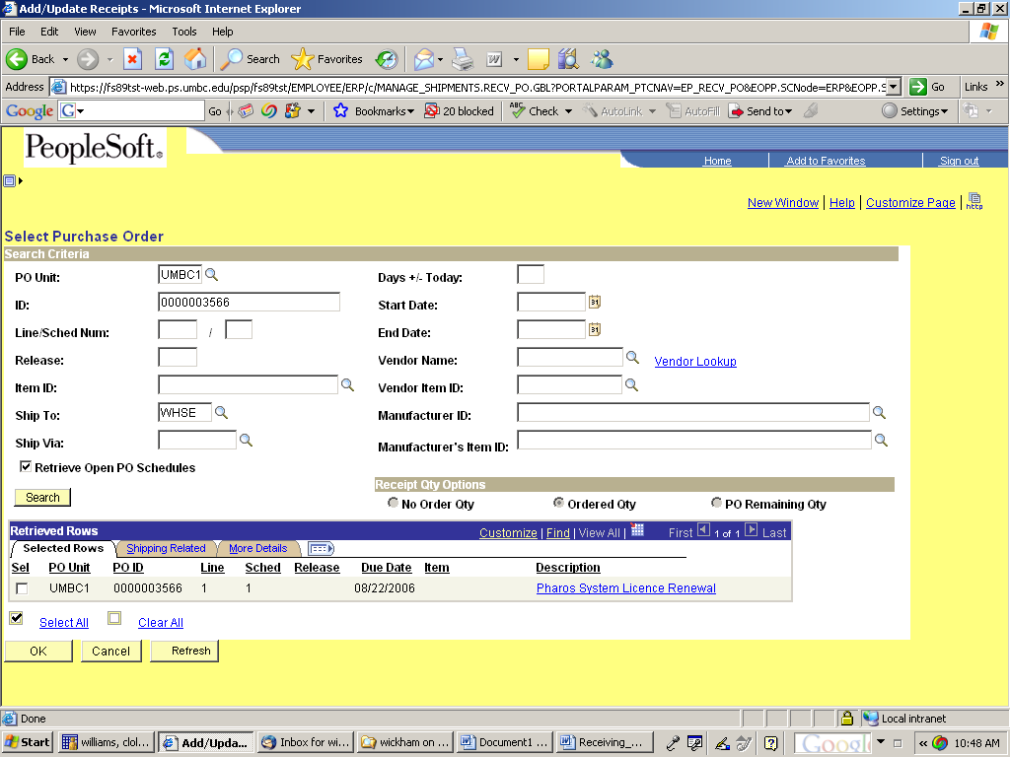

- Click on the Sel (Select) check boxes for the lines that you want to receive. Click

The Maintain Receipts page will open.

- Enter the quantity of each item received, in the Receipt Qty field.
NOTE: If this line is being received in dollars, you will see a field called “PRICE” next to Receipt QTY. In this case, enter the dollar amount you wish to approve for payment, in the Price field. The Receipt Qty field will not be active.

- After you enter the quantity or dollar amount that is on your invoice, click on the Receiving page and you will see the receipt ID on top of the page as shown below. Enter the receipt # on your invoice with the purchase order # and send the invoice to accounts payable for processing.

CANCELLING RECEIPTS
1. Navigation: Purchasing Receipts Add/Update Receipts

2. Click the Find an Existing Value tab.

3. Enter your receipt number.

4. Click on the red X

5. Message above will appear when you click on the red X. Click yes.

6. The receiving screen will come back with the receipt status stating that the receipt is canceled.

