Online Requisition Quick Reference Guide

1. To create a Requisition, navigate to the Maintain Requisition page:

Purchasing Requisitions Add/Update Requisitions
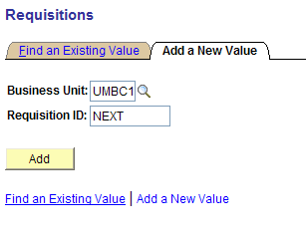

2. Click (Do NOT delete the word “NEXT” in the Req ID field. PeopleSoft automatically numbers each requisition that is entered into the system.)
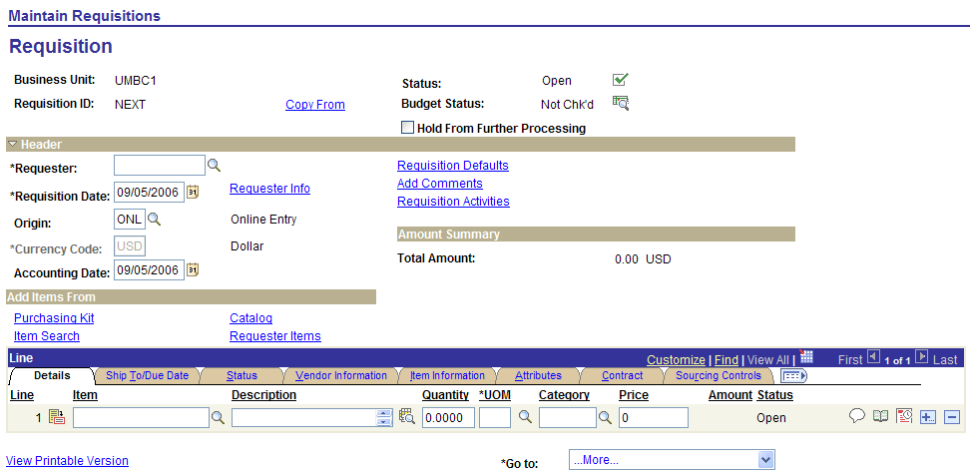

Maintain Requisition Page
3. Select a Requestor using the Search Icon.
4. Enter information on the Line Detail area.
5. If you need more than one line on a requisition, you will need to add additional lines. To insert
additional lines, click the “plus sign” icon .
6. For each Line Detail, complete the Description, Quantity, UOM, Category ID, and Price.
7. Click the Add Comments link on the Maintain Requisition page to add any necessary
comments pertaining to the entire requisition; i.e., the vendor is not in the system, direct delivery
location.

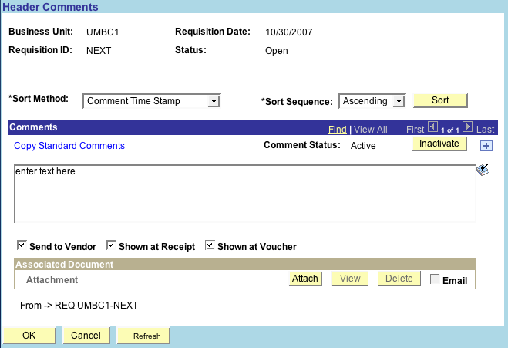
a. Enter text in the Comments text window.
b. Select the following boxes.
Click to return to the Maintain Requisition page.
8. Attaching Documents
There will be times when you will need to submit backup paperwork for a requisition such as a contract, Terms and Conditions, quote or a sole source. It is preferred that you do an on- line attachment in the requisition module in PeopleSoft.

Before attachments can be added to the requisition, the hard copies will need to be scanned and saved to a directory.

a. Click the Add Comments link on the Maintain Requisition page to add an attachment.

b. Click on the Attach tab

c. Click on the Browse

d. Choose the file that you want to attach.
e. Click the Upload tab. To attach multiple documents, click the plus sign next to the word Inactivate above the comments box and follow the same above instructions for adding attachments.
f. Type in the word “Attached” and what the attachment is in the Comments Text
Window. Select the three boxes – click OK to return to the Maintain Requisition
page.

9. Click the Requisition Defaults link.
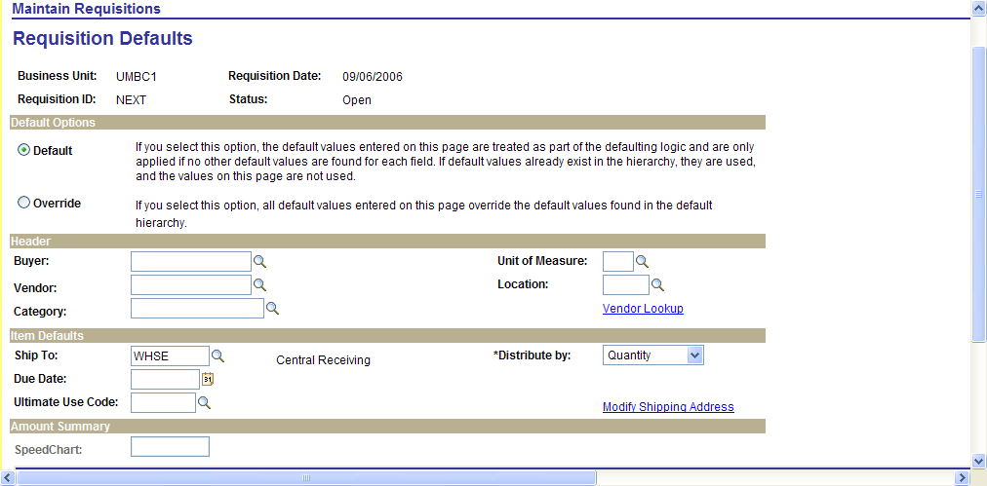
a. Click the Buyer search icon for a list of approved Buyers.
b. Enter a Vendor ID, or click the Vendor search icon for a list of Vendors. To conduct an
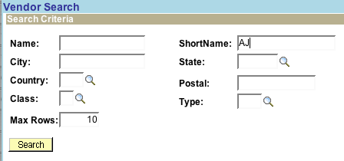
advanced search for a Vendor, select the Vendor Lookup link.

Type in the first few letters of the vendor name in the ShortName Box. Click Search.
A list of results is displayed.
c. Select the appropriate Vendor. Note: You should select a Vendor whose Address
Description is listed as ORDER.
d. Click .
Note: In some cases the vendor is not listed in the PeopleSoft vendor file. In that case enter the vendor name, address and FID number in the ADD COMMENT link on the Maintain Requisition page.
e. Distributions:
From the Requisition Defaults page scroll down to the Distributions Details line.
Enter the Percentage (100).
Required Chartfield includes: Percentage, GL Unit, Tcode, Fund, Prog Fin, Department.
NEVER ENTER AN ACCOUNT NUMBER. THE CATEGORY ID # THAT YOU ENTER IS LINKED TO THE ACCOUNT # WHICH THE SYSTEM WILL AUTOMATICALLY ENTER.
NOTE: GL Unit should be UMBC1 and Tcode should always be 242.
If distributing to a Project, the following additional ChartFields must be completed: PC Business Unit (UMBC 1), Project and Activity ID.

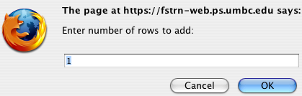
Note: There may be times when you wish to distribute the expense to more than one chartstring. When this is the case, after adding the Line Detail information, click the Schedule icon at the far right side of the Line Detail text box. This will return you to the Maintain Requisitions page. Click the Distribution icon . Then click the plus sign at the far right of the distribution line and indicate how many additional rows you want to add in the dialog box that appears at the top of the screen. The default is 1. Then click OK.
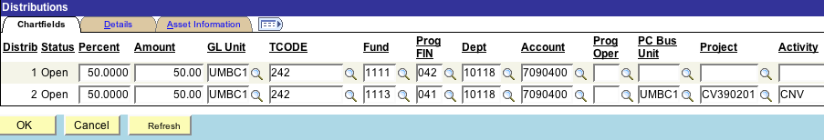
The new line is added and you can add the additional chartstring information. You must change the percent from 100 to whatever percentage you need to distribute the cost over the two chartstrings.
Note: There may be times when the Chartstring you entered in the Requisition Defaults page does not carry over for the entire requisition. When this is the case, in the line detail information on the Maintain Requisition page, click the Schedule icon at the far right side of the detail line. This will bring you to the Schedule page. Click the Distribution icon . Check the Distribution line to make sure that your Chartstring is correct.
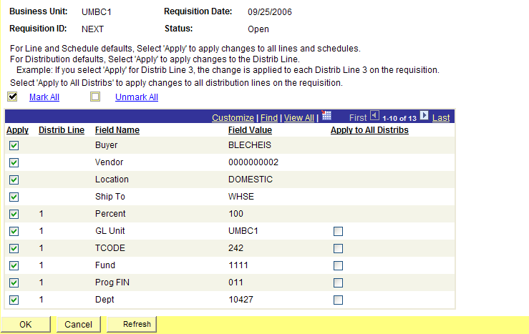
10. Click . The Mark All screen will appear on the screen.
11. Click the Mark All Link. The checkboxes in the Apply column are selected.
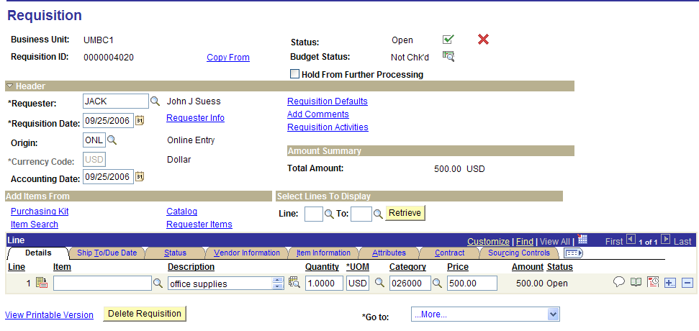
12. Click. . You will be returned to the Maintain Requisition page.

13. Click to SAVE your Requisition. The Requisition ID number field is populated.

14. Printing Requisitions

To print your requisition before approval from your approver, click on the View Printable Version link on the Maintain Requisitions page. Note that your Requisition must be saved prior to printing it. You will be prompted to do so during the printing process. After clicking OK, you will get an error message stating that you do not have permission required to run the window option. Click OK. On the menu click People Tools and follow the breadcrumbs below:
Process Scheduler Process Monitor Click refresh until your run status states success Click details (highlighted in blue) Click view Log/Trace Click on PDF Link Print requisition

Change Orders:

Remember that NO CHANGES can be made online to a Requisition once it has been approved.

If any changes need to be made on the requisition or if the requisition has been sourced to a PO
and changes need to be made, you will need to submit the change to Procurement by entering a
requisition in PeopleSoft.

When entering the description on the Maintain Requisition page, you will need to type CHANGE ORDER and what changes need to be done on the purchase order. (Reference the Purchase Order #). Click on the Add Comments link on the Maintain Requisition page and type CHANGE ORDER to PO #_______ in the comments box and check the three
boxes.

