REQUISITIONS – NEW FISCAL YEAR

This script provides instructions for entering requisitions for orders being charged to FY 18.

TO ADD A REQUISITION FOR A FUTURE FISCAL YEAR:

1. On the Requisition page, change both the Requisition Date and Accounting Date to 7/1/17.

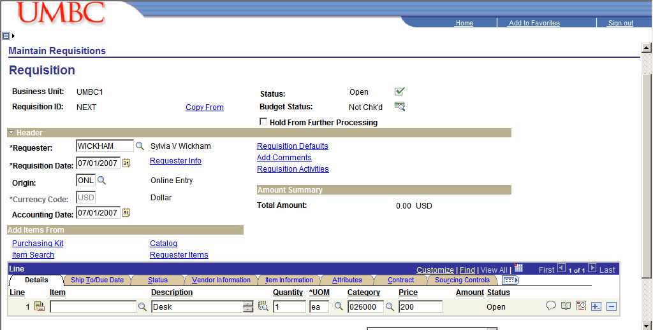
7/1/2017
7/1/2017

2. You may receive a warning message like the one above. Click OK to clear the message.

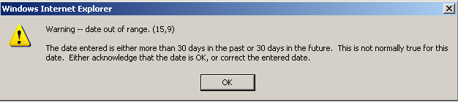

.

3. Click on the schedule symbol to the right of the page on the description line on the Requisition page.

7/1/2017
7/1/2017

4. Click on the distribution symbol to the right of the due date on the Schedule page.

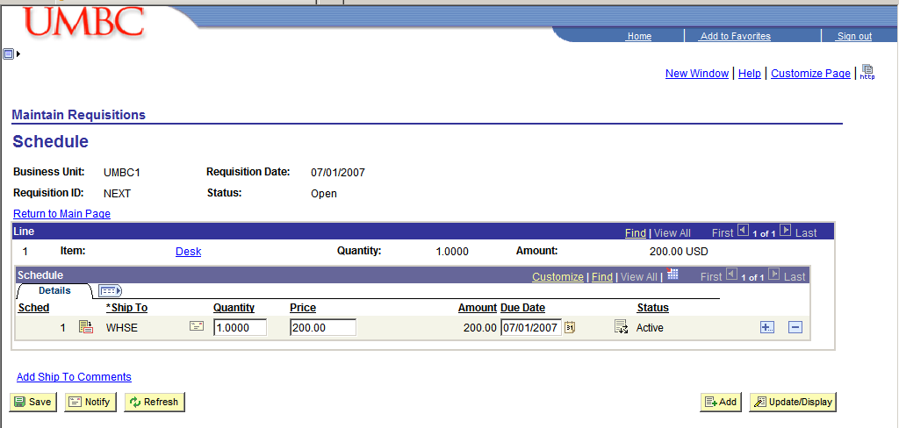
07/01/17
07/01/17

5. Click on the detail tab on the distribution page.

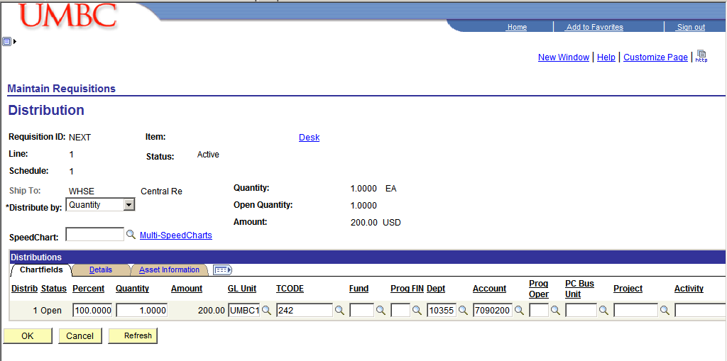

6. Change the Budget Date to 7/1/17 on the Distribution page.

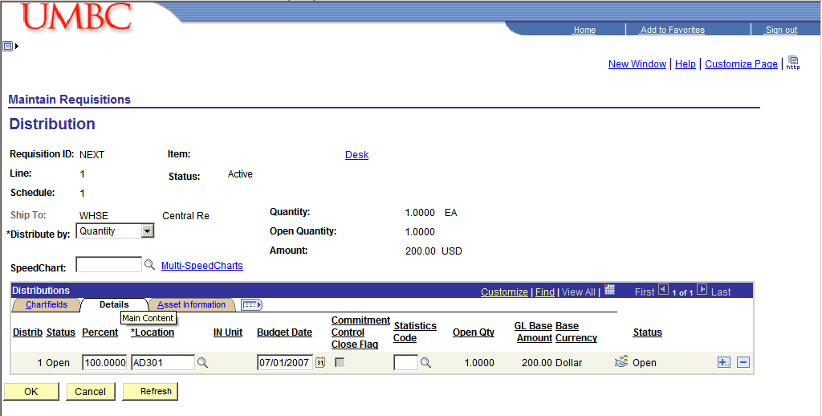
7/1/2017

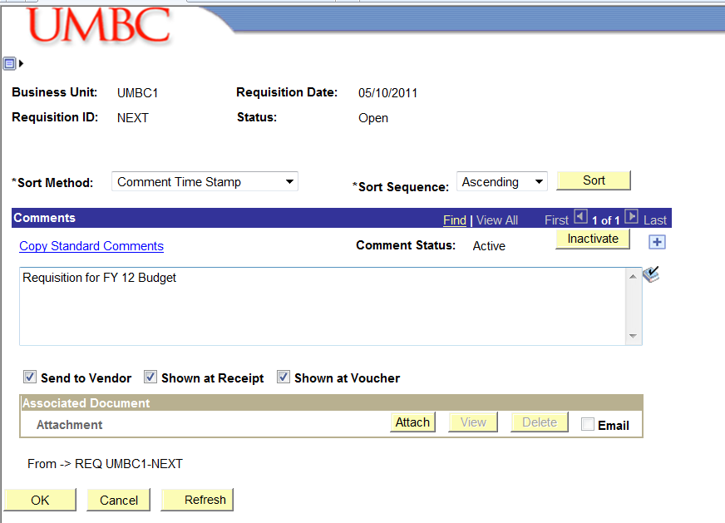
7. In the Add Comments link – enter the text “Requisition for the FY18 Budget”.
Requisition for FY 18 Budget
07/01/17

